Introduction
Project title: AI BlogNest API
Team ID : SWTID-2026-5758
Team Size : 4
Team Leader : Sandhiya C
Team member : Shanthini C
Team member : Samprutha S
Team member : Arthi A

1.Project Overview

AI BlogNest is an AI-powered blog creation and management web application that helps users create, edit, publish, and manage blog posts easily. It uses Artificial Intelligence (AI) to generate blog content based on the topics provided by users.

The main aim of this project is to reduce the time and effort required for writing blogs and make content creation easier and more efficient.

2.Project Objectives

1.To develop an AI-based blogging platform for creating and managing blog posts easily.

2.To generate blog content using Artificial Intelligence based on the topic or keywords provided by the user.

3.To reduce the time and effort required for manual blog writing.

4.To provide a simple and user-friendly interface for creating, viewing, editing, and deleting blogs.

5.To securely store user and blog information using a database.

6.To provide REST APIs for communication between the frontend, backend, database, and AI service.

7.To help users improve their content creation process by providing AI-assisted ideas and content.

8.To provide an organized platform where users can manage all their blogs in one place.

3.Target users

The main target users of AI BlogNest are people who want to create and manage blog content easily with the help of Artificial Intelligence.

1.Students – To create educational blogs, assignments, and project-related content.

2.Bloggers – To generate ideas and create blog posts quickly.

3.Content Writers – To get AI assistance for drafting and improving content.

4.Teachers and Educators – To create educational articles and learning materials.

5.Small Business Owners – To create promotional and informational blog content.

6.Beginners – Users who want to start blogging without advanced writing skills.

4.Pre-requisite & knowledge requirements

Pre-Requisites
Before developing the AI BlogNest project, the following are required:

1. A computer or laptop with a stable internet connection.

2. VS Code or any suitable code editor.

3.Node.js and npm installed for backend development.

4.A database such as MongoDB for storing user and blog
information.

5.An AI API key for AI-based blog content generation.

6.A modern web browser such as Chrome, Edge, or Firefox.

7.Postman for testing the REST APIs.

Knowledge Requirements
The developer should have basic knowledge of:

HTML, CSS, and JavaScript – for frontend development.

Node.js and Express.js – for creating the backend and REST
APIs.

MongoDB – for database operations.

REST API concepts – for communication between frontend and
backend.

JSON – for transferring data through APIs.

AI API integration – for generating blog content.
Basic authentication concepts – for user registration and login.

CRUD operations – Create, Read, Update, and Delete blog posts.

5.Project architecture and tech stack
AI BlogNest
|
┌───────────┴───────────┐
↓ ↓
Frontend AI Service
↓ ↑
Backend / REST API ──────────┘
↓
Database

1. Frontend Layer
The frontend provides the user interface.

Responsibilities:
User registration and login
Dashboard
Create blog
AI blog generation
View, edit, and delete blogs
Technologies: HTML, CSS, JavaScript

2. Backend Layer
The backend processes requests from the frontend and communicates with the database and AI service.

Responsibilities:
User authentication
Blog CRUD operations
REST API handling
AI API integration
Data validation and error handling
Technologies: Node.js, Express.js

6.Project setup and configuration

The following software is required to set up the AI BlogNest project:
VS Code – Code editor
Node.js & npm – Backend development
MongoDB – Database
Postman – API testing
Web Browser – To run the application
Git/GitHub – Version control

mkdir AI-BlogNest
cd AI-BlogNest
npm init -y
npm install express mongoose cors dotenv bcryptjs jsonwebtoken

These packages are used for:
Express.js – Creating REST APIs
Mongoose – Connecting Node.js with MongoDB
CORS – Allowing frontend-backend communication
dotenv – Managing environment variables
bcryptjs – Password encryption
jsonwebtoken – User authentication

7. Features&api endpoints

Main Features

1.User Registration
New users can create an account.
User details are stored in the database.

2.User Login
Registered users can securely log in.
Authentication is used to protect user-specific features.

3.AI Blog Generation
User enters a topic or prompt.
AI generates suitable blog content automatically.

4.Create Blog
Users can create and save their own blog posts.

5.View Blogs
Users can view available blogs and their own posts.

6.Edit Blog
Users can modify the title or content of an existing blog.

7.Delete Blog
Users can remove unwanted blog posts.

8.Dashboard
Provides access to blog creation, AI generation, and blog management features.

9.Database Management
User and blog information is stored and retrieved from MongoDB.

8.Project flowchart

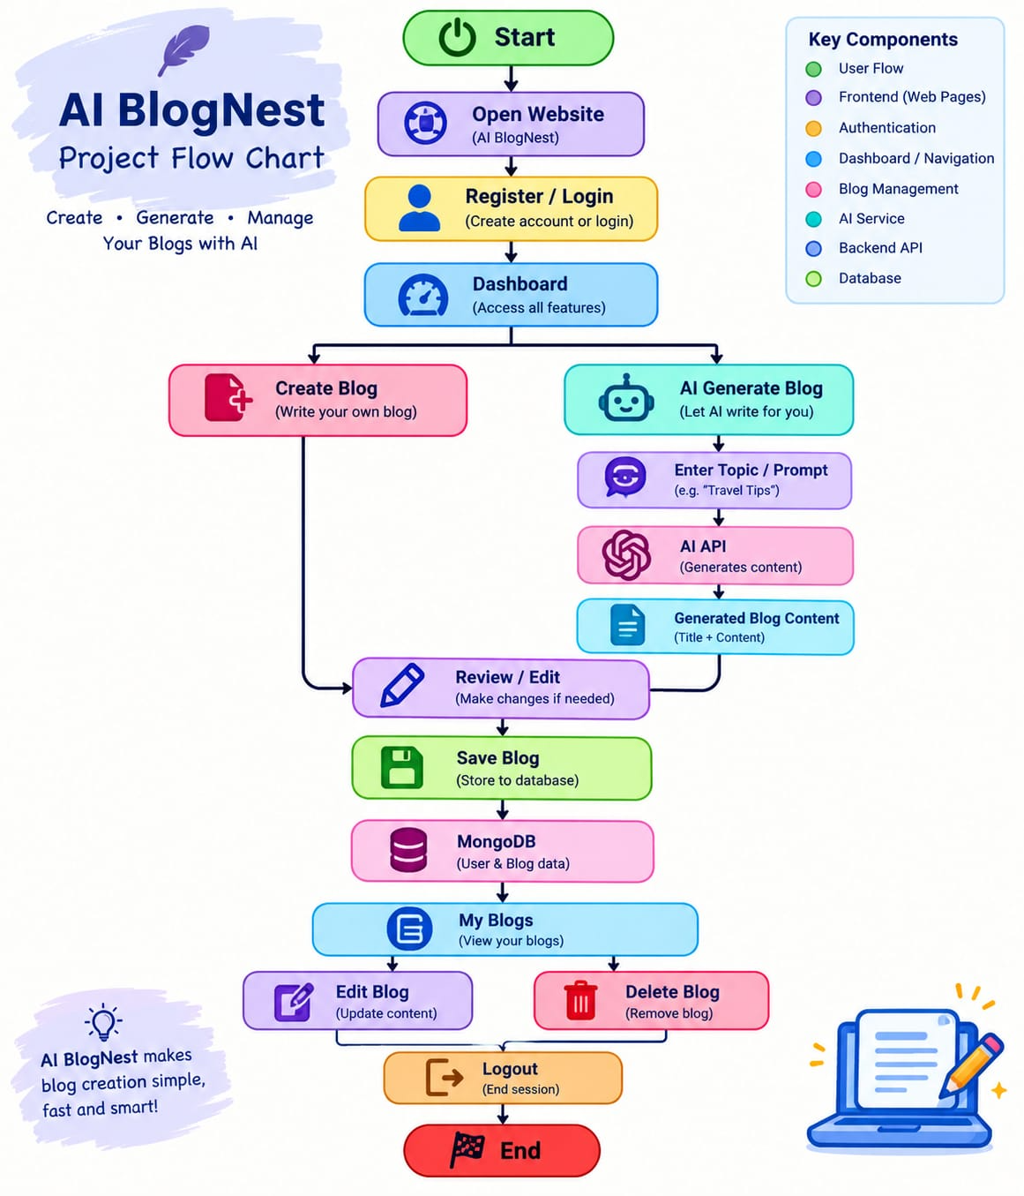

9. Output
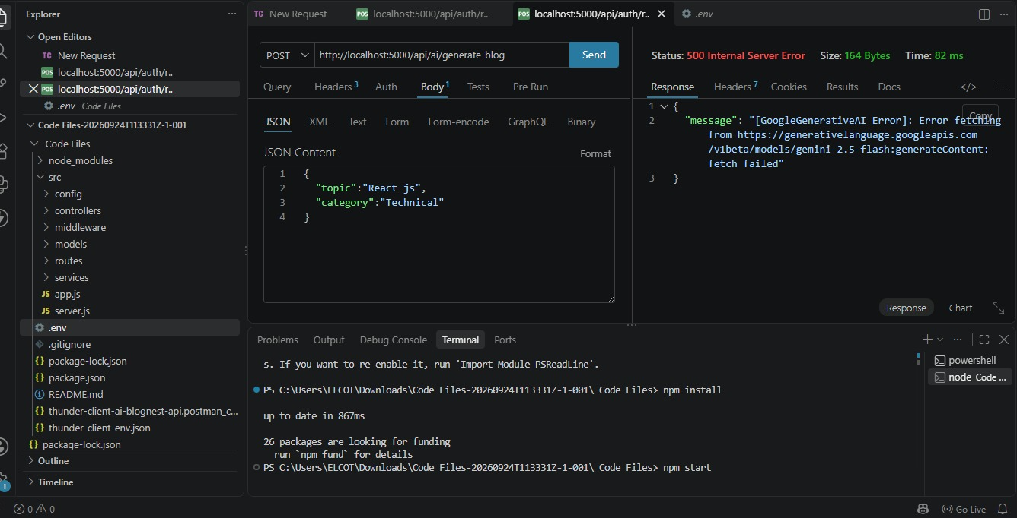

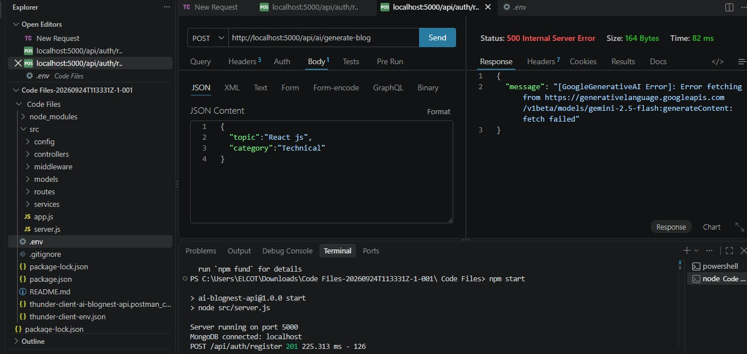

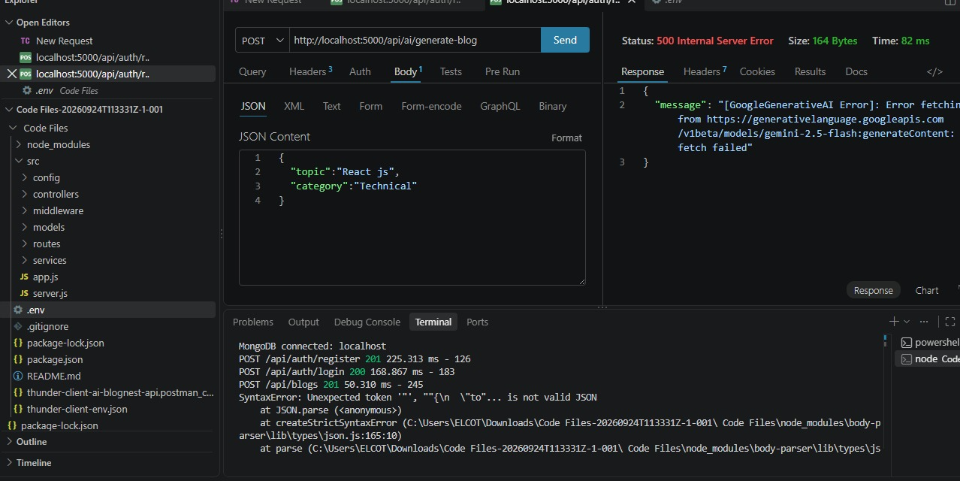

10.Conclusion

AI BlogNest is an AI-powered web application designed to make blog creation and management simple and efficient. It allows users to create, edit, view, and delete blogs while using AI to generate content based on a given topic.

The project combines frontend technologies, backend REST APIs, MongoDB, and AI services to provide an integrated blogging platform. It reduces the time and effort required for content creation and provides a user-friendly experience.

Overall, AI BlogNest demonstrates how Artificial Intelligence can be integrated with web applications to improve and simplify digital content creation.

